What is provider in flutter?
provider is a state management package that makes it easier to manage and share state across your app. It provides a way to expose and listen to data changes, ensuring that your widgets rebuild only when necessary. This is achieved using a combination of ChangeNotifier and Provider.
Note: Provider is a way to pass data between different node of widget tree.

List of all the common methods to use in Original Providr:
- Read(): Reads the current value of a provider without subscribing to updates. This is useful when you only need the value once and do not want the widget to rebuild.
Example: final value = context.read<YourModel>();

- Watch(): Listens to changes in the provider. When the value changes, the widget that uses this method will rebuild to reflect the new value.
Example: final value = context.watch<YourModel>();

- Listen(): Similar to watch(), but instead of rebuilding the widget, it allows you to run a callback function when the value changes. This is useful for side effects.
Example: context.listen<YourModel>((model) {
// Execute code when model changes
});

- Select(): Allows you to listen to a specific property of the provider. This can optimize performance by only rebuilding the widget when that specific property changes.
Example: final specificValue = context.select<YourModel, SpecificType>((model) => model.specificProperty);

- Notifylistener(): This method is part of the ChangeNotifier class. Call this method in your model to notify all listeners that the value has changed, triggering a rebuild of any widgets listening to this provider.
- Provider.of<T>(context): This method allows you to directly access the provided value. You can specify whether you want to listen for changes by passing a listen argument.

What is Consumer Widget?
The Consumer widget in the Flutter Provider package is a widget that listens to changes in a specified provider and rebuilds only the part of the widget tree that depends on that provider. It allows you to access the provider’s value and build a widget based on that value, optimizing performance by minimizing unnecessary rebuilds.

Notes:
- Selective Rebuilding: Only rebuilds when the provider’s value changes.
- Access to Provider: Allows easy access to the provider’s state within its builder method.

What is MultiConsumer Widget?
The MultiConsumer widget in the Flutter Provider package allows you to listen to multiple providers at once. It enables you to rebuild a part of the widget tree based on changes from several providers, efficiently managing dependencies and optimizing performance.

Notes:
- Multiple Providers: Listen to and react to changes from multiple providers.
- Selective Rebuilding: Only rebuilds when any of the listened providers' values change.

Needs of Original Provider:
- Better Performance
- Easy to handle the data
- Update UI in Real-Time.
- Production Level App.

Types of Original Providers:
- Provider.
- ListenableProvider
- ChangeNotifierProvider.
- FutureProvider
- ValueListenableProvider.
- StreamProvider.
- MultiProvider.
- ProxyProvider.
- ChangeNodifierProxyProvider.

Note: An efficient way to update or pass the data between UI or Widget tree.

Types of Way to Declare Original Provider
- Single Provider:
- Multi Provider.

Single Provider
A Single Provider is used when you want to provide a single instance of a class (like a ChangeNotifier, a service, or any other object) to the widget tree. This is the most straightforward way to use Provider.

Example:
void main()
{
runApp( ChangeNotifierProvider( create: (context) => Counter(), // Providing a single instance of Counter
child: MyApp(), ), );
}

MultiProvider
MultiProvider allows you to provide multiple providers at once. This is useful when your application requires multiple instances, states or services, making your code cleaner and more organized.
Example:
MultiProvider(
providers: [
ChangeNotifierProvider(create: (_) => Increment()),
ChangeNotifierProvider(create: (_) => Decrement())
],
child: const DemoMultiConsumer(),
),

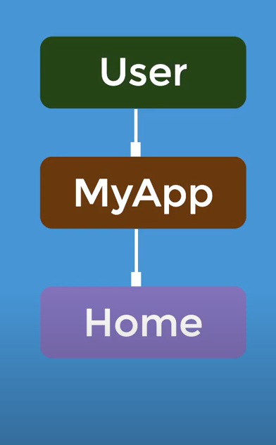

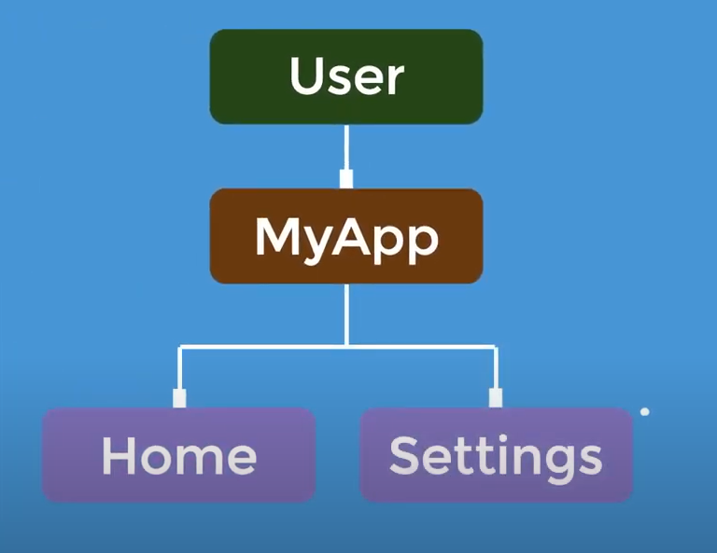
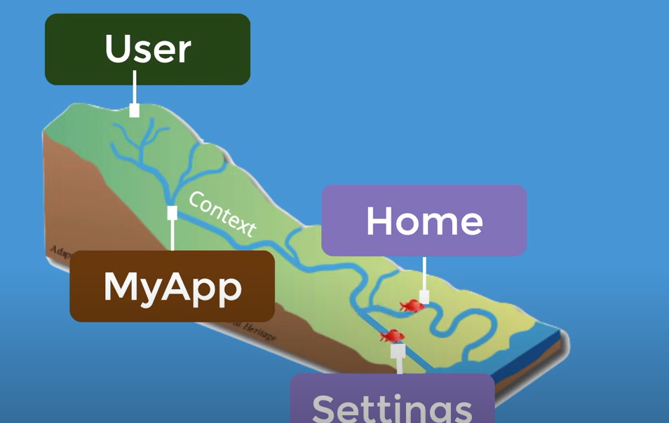
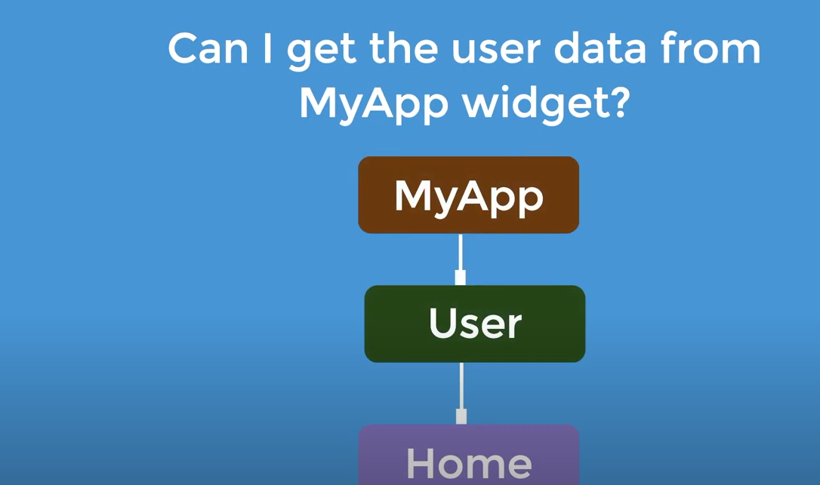
Answer is no because provider should be at the top of the model of your app so it will flow down not a back word like a river so based on the case, we should always create a provider at the top of the model of your app.

Multi Provider
- Merges multiple Providers into a single linear widget tree.
- Improve readability and reduce boilerplate of creating many many providers.
Combine two codes into one
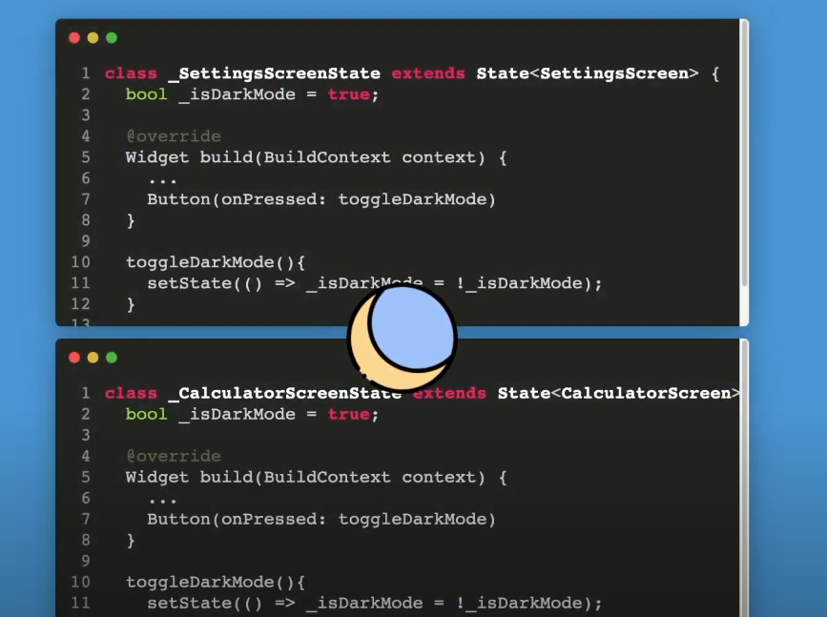
To combine these codes into a single code it needs a provider called ChangeNotifier provider.
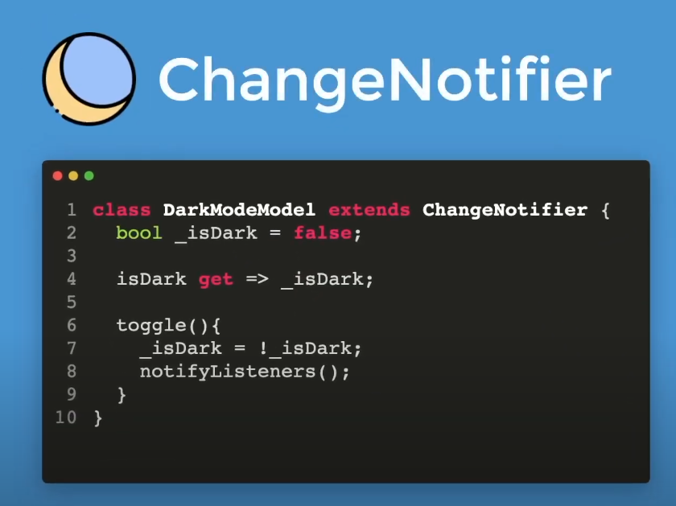
Why do we make the _isDark variable private?
It is because to avoid the variable _isDark to overwrite with other widgets and to make the variable the private.
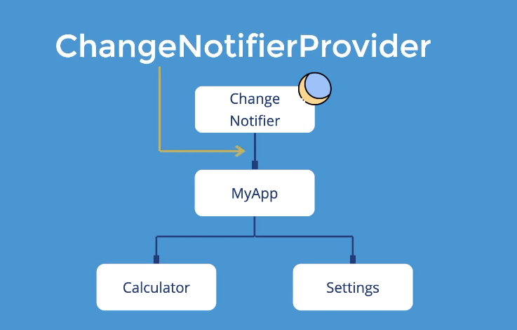
Note: Change Notifier will provide dark mode model to each decedent to all to the bottom of the widget.
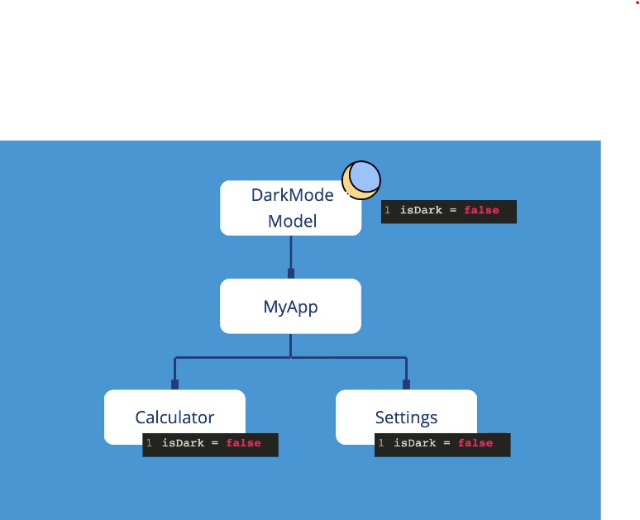
Note: In this case if a dark mode is change the other widgets like calculator and settings listen all because of provider widget.

